**Smart Sorting** :

Transfer Learning for identify in Identifying the rotten fruits and vegetables

**Team id: LTVIP2025TMID41934**

**TEAM LEADER: Puvvadi Padmaja**

**Team member: Naguru vaishnavi**

**Team member:** Naru shireesha

Team member: Roohi

**Team member: Rajanala Ganga Bhavani**

**College: Kandula Lakshumamma Memorial College of Engineering for women.**

**Project Introduction:**

*Introduction to Smart Sorting: Transfer Learning for Identifying Rotten Fruits and Vegetables*

The Smart Sorting project utilizes transfer learning to develop a deep learning-based system for identifying rotten fruits and vegetables. By leveraging pre-trained models and fine-tuning them on a dataset of images, the system can accurately classify produce as fresh or rotten. This technology has the potential to revolutionize the agricultural industry by reducing food waste, improving quality control, and enhancing efficiency.

**Key Benefits:**

**1.Accurate Identification:** Precise classification of rotten fruits and vegetables.

**2.Efficient Sorting: Streamlined sorting process, reducing labor costs and increasing productivity.**

**3. Reduced Waste: Early detection and removal of rotten produce, minimizing food waste.**

**Applications:**

**1. Agricultural Industry: Improved quality control and reduced waste in fruit and vegetable production.**

**2. Food Processing: Enhanced food safety and quality by identifying rotten produce before processing.**

**3. Retail: Efficient identification and removal of rotten produce from shelves.**

Technology:

**1. Transfer Learning: Utilization of pre-trained models for image classification.**

**2. Deep Learning: Development of a robust and accurate classification system.**

**By harnessing the power of transfer learning and deep learning, the Smart Sorting system offers a promising solution for improving the efficiency and effectiveness of fruit and vegetable sorting.**

**project overview:**

Project Purpose: Smart Sorting Transfer Learning for Identifying Rotten Fruits and Vegetables*

The purpose of the Smart Sorting project is to:

1. Develop a robust image classification system* using transfer learning to identify rotten fruits and vegetables.

2. Improve quality control in the agricultural industry by reducing food waste and enhancing efficiency.

3. Provide a reliable solution for identifying rotten produce, enabling timely removal and minimizing losses.

purpose:

The purpose of the Smart Sorting project is to develop a system that uses transfer learning to identify rotten fruits and vegetables, with the goal of:

1. Reducing food waste

2. Improving quality control

3. Enhancing efficiency

4. Increasing food safety

By achieving these goals, the project aims to benefit the agricultural industry, food processing, and retail sectors, ultimately contributing to a more sustainable food system.

Senories :

Here are some potential types of scenarios for the Smart Sorting project:

1. *Agricultural Scenarios:*

- Farm-level sorting

- Packing house sorting

- Wholesale market sorting

2. *Retail Scenarios:*

- Supermarket shelf management

- Store-level inventory management

- Customer-facing product quality assurance

3. *Food Processing Scenarios:*

- Raw material inspection

- Quality control during processing

- Finished product inspection

4. *Food Distribution Scenarios:*

- Food bank sorting and distribution

- Food rescue operations

- Logistics and transportation management

5. *Research and Development Scenarios:*

- Crop health analysis

- Produce quality monitoring

- Development of new sorting technologies

These scenarios can help identify potential use cases and applications for the Smart Sorting technology.

Architecture:

. 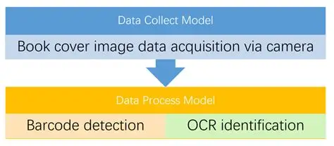

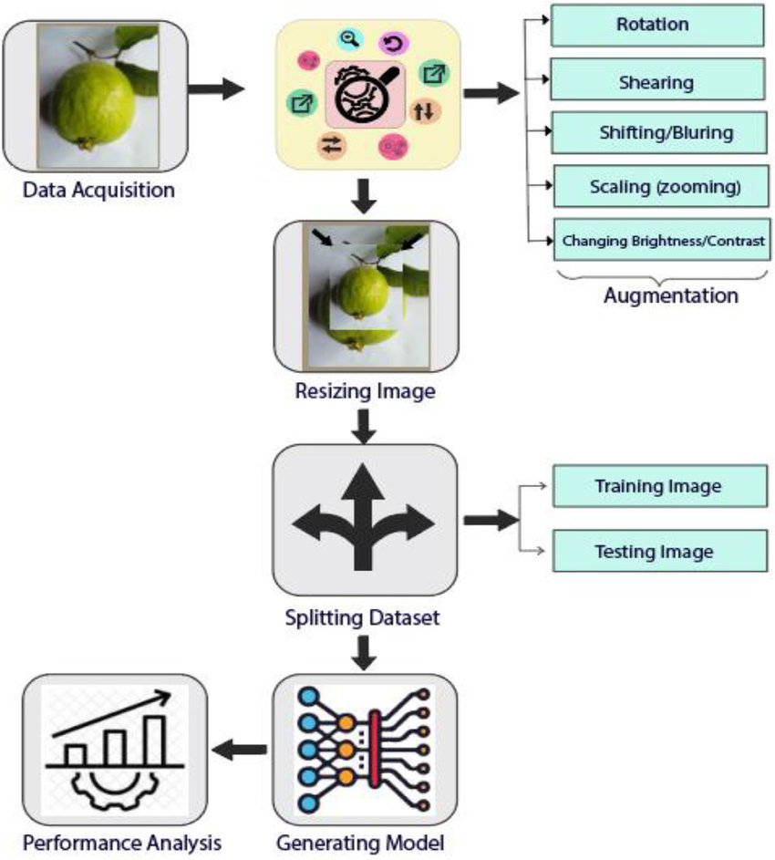

IDEATION STATEMENT:

Problem Statement:

Rajasthan faces significant challenges in waste management due to rapid urbanization and inadequate disposal infrastructure, leading to environmental pollution and health hazards. More focus is on ensuring circular economy in the State. We invite you to develop innovative solutions to enhance waste collection, segregation, recycling, and disposal processes. Leverage IoT, AI, and data analytics for real-time waste monitoring, smart bins, and automated sorting. Ideas could include mobile apps for waste reporting, advanced recycling techniques, waste to-energy solutions, and creating new products from recycled materials. Explore decentralized waste treatment, biodegradable packaging, and community engagement initiatives. Together, let's create a cleaner, healthier, and more sustainable Rajasthan.

EMPATHY MAP CANVAS:

**Use the empathy map canvas template to develop robust personas and inform decisions that improve the user experience. Get teams on the same page and create a visual representation of a customer’s thoughts, feelings, actions, and observations.**

**Empathy maps serve as a foundation for outstanding user experiences and new products that focus on providing the experience customers want rather than forcing design teams to rely on guesswork and assumptions.**

**The empathy map template helps you:**

* **Build deep empathy for the user and their experience**
* **Create a user persona collaboratively with stakeholders in real-time**
* **Understand user needs and wants using design thinking methods**
* **Improve decision-making in the design process**

**How to use the empathy map canvas template:**

**While most empathy maps are divided into four quadrants, this empathy map canvas template uses more segments, which are typically defined by questions that teams work to answer one by one to complete the map.**

Step 1: **Identify your primary user or customer and what motivates them**

**Who is the the person you want to understand and empathize with? Start outlining the basics of the persona so your team has information to start building upon.**

**Step 2: Record what customers/users are thinking and feeling**

**First, go over pain points. What are their fears, frustrations and anxieties? If your team comes up empty with ideas, try conducting user interviews to understand user attitudes and thought processes.**

**Once you have identified what their pains are, move into gains. What are their wants, needs, hopes and dreams? Be sure to log any other thoughts and feelings that might influence user behavior.**

Step 3**: Review what users are saying and doing**

**Answers to this question should come from interviews with customers, survey responses, or any other channel that provides direct feedback from customers. Try to include direct quotes from users in this section, such as, “I love this product; it saves me so much time every week.”**

**Be sure to include data about how the end user interacts with the platform or brand, including things like idle time, contacting support, or changing subscription plans. These objective metrics can help you measure and track improvements over time.**

Step 4**: What are users seeing and hearing?**

**To answer these questions, think about the persona’s environment and the outside influences that surround them, including friends, colleagues, and media outlets. For example, their friends might discuss products they use at work or read an industry publication that ranks best-in-class productivity tools.**

**Don't forget other more subtle influences, like if they see a colleague in the office with a product that appears to be helping improve productivity.**

**It’s also important to ask what a customer stands to gain from using the product. Determine what pain points it solves by asking questions like, “What obstacles are customers trying to overcome?” or “How do users measure success/effectiveness?”**

Step 5**: Define next steps**

**Analyze your findings and start outlining what changes need to be made in order to improve the customer experience.**

**Tips for creating empathy maps**

* **‍Create multiple personas: User bases are varied, consisting of many individuals who might have different reasons for using the platform. Relying on a single persona won’t provide an accurate picture of who the average users are or what they need.‍**
* **Customize the template outline to support your team: This template allows the board’s creator to edit the outline to provide clear and tailored instructions that help team members brainstorm and answer key questions.‍**
* **Use a photo to help visualize the user: Including a visual representation for your persona will help your team better brainstorm how the user feels, thinks, and acts. Choose a stock image that best represents your customer or user persona.‍**
* **Pair your empathy map canvas with a customer journey map: Now that you’ve conducted this user research with your team, put it into action by mapping out the customer journey to understand more pain points they experience throughout the process.**

Brainstorming:

The Smart Sorting system using transfer learning has shown promising results in identifying rotten fruits and vegetables. By leveraging pre-trained models and fine-tuning them for specific tasks, we can develop accurate and efficient sorting systems. This technology has the potential to reduce food waste, improve food safety, and increase efficiency in the food industry.

Key Takeaways:

1. Transfer learning: Utilizing pre-trained models can improve accuracy and reduce training time.

2. Image classification: Deep learning architectures like CNNs can effectively classify images of fruits and vegetables.

3. Smart sorting: Automated sorting systems can streamline the sorting process, reducing labour costs and increasing efficiency.

Future Directions:

1. Expanding dataset: Collecting and annotating a larger dataset can further improve model accuracy.

2. Exploring other architectures: Investigating other deep learning architectures and techniques can lead to even better performance.

3. Real-world implementation: Implementing the Smart Sorting system in real-world settings can help reduce food waste and improve food safety.

**REQUIREMENT ANALYSIS:**

**Customer journey map:**

A customer journey map helps you gain a better understanding of your customers so you can spot and avoid potential concerns, make better business decisions and improve customer retention.

The map helps you see which touchpoints your customers love, so you can emphasize those, and where there are common pain points you want to improve.

You can use the map to create standard operating procedures in your business, train your staff, help all team members better understand your customers, and improve your product or service for a better user experience.

**Elements of a Customer Journey Map**

**Customer Persona**

You can’t understand your customer’s experience until you know who your customer is. If you haven’t already.

A phase is the general stage of decision making and purchasing the customer is in. You can break down [buying stages](https://www.forbes.com/sites/forbesbusinesscouncil/2020/03/27/what-to-know-about-the-buyers-journey-and-customer-life-cycle-and-how-to-use-them-both/?sh=2683deb91472) in several ways, but here’s a basic outline:

**Awareness:**

The customer realizes they have a need, problem or opportunity.

**Research:** They research solutions to determine whether to make a purchase and evaluate options.

**Consideration:** They decide they’ll make a purchase to address their need, and they narrow down their options.

**Purchase:** They choose a solution and buy it.

**Support:** The customer uses the product or service, engages with the company and decides whether to purchase again.

**Touchpoints:**

Touchpoints are every interaction the customer has with your brand throughout the buying journey. Phases may each include several touchpoints.

The touchpoints of your customer’s journey depend on your approach to marketing, sales, product and customer service. They might include things like:

* Marketing collateral, like posters, stickers, billboards, flyers, commercials or display ads
* Physical properties, including your storefront or office space
* Digital properties, including your website and social media pages
* Interactions with your staff, such as cashiers, customer service reps and sales reps
* Purchase experience, including the price and checkout process
* Any post-purchase follow-up from your company, like an email or phone call
* Ongoing customer support
* Renewal or cancellation of your service

**Customer Thoughts, Actions and Emotions**

This is where you plot the precise [**customer experience**](https://www.forbes.com/advisor/business/customer-experience-cx/)at each touchpoint. What are they thinking to themselves? Which steps do they take? How are they feeling?

Don’t guess at this information! Get [real feedback from your customers](https://www.forbes.com/sites/forbestechcouncil/2019/09/25/better-than-csat-surveys-really-knowing-your-customers-are-happy/?sh=290445e3e46c) through surveys and—even better—live interactions with your customer support staff. Basic CSAT (customer satisfaction), NPS (net promoter score) and CES (customer effort score) questions are a great place to start.

**Opportunities**

Once you’ve plotted your customer journey, you can include room to note opportunities based on what you see on the map.

Opportunities are anywhere you can remove pain points and improve the buying journey for your customer—where are your customers hitting roadblocks that keep them from buying (or coming back)?

**Six Steps to Creating a Customer Journey Map**

To create a customer journey map:

1. **Decide what to measure.** Get clear on your goals, so you know what to look for as you plot your customer journey.
2. **Create your customer persona.** Start with knowing which buyer you’re focused on and what their general needs and wants are.
3. **Define your customer buying phases.** What are the stages your customer goes through between discovering their problem and deciding to purchase your product or service? Which stages happen after purchase?
4. **Plot your touchpoints.** Within each phase, where does your customer interact with your brand?
5. **Add customer thoughts, actions and emotions.** At each touchpoint, what is the customer prompted to think, do and feel?
6. **Note your opportunities.** Based on your goals and what you discover through your customer journey map, which changes can you make at each touchpoint or within each phase to improve the customer experience?

There’s no correct way to design your customer journey map.

You could build it in a simple spreadsheet that includes swimlanes for phases, touchpoints, thoughts/actions/feelings and opportunities. Some journey maps are more intricately designed, with touchpoints and emotions illustrated and wrapped .

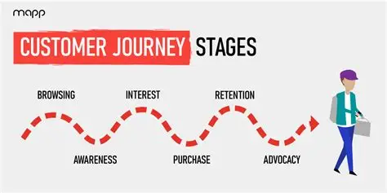

Solution requirement:*Solution requirements* in a business analysis specify the conditions and capabilities a solution has to have in order to meet the need or solve the problem and provide clarity around delivery needs. They don’t define how the solution will solve the problem technically or specifically; that happens later. Solution requirements must meet or support the driving project and business objectives, in addition to meeting stakeholder objectives.

When developing solutions or solution concepts, stakeholders commonly focus first on identifying and writing software requirements and worry about the rest of the requirements later.

But doing that without really knowing which features or functions will be most valuable in meeting the business and stakeholder requirements means your team may end up building some cool stuff without actually solving any important problem. You can’t really be sure what capabilities will be truly valuable until the overarching solution vision is clear.

People get excited by technology or by finding great opportunities to improve. At this stage, beginning to brainstorm approaches or evaluate how something may be done or designed is very easy. Don’t let that happen! Instead, brainstorm about what the solution has to achieve for stakeholders before everyone gets caught up in the details of how to build it.

How to use a vision statement to define the solution in a business analysis

A *vision statement* articulates and defines the holistic need for the solution. It’s the most important of all the solution requirements. The vision specifies which conditions and capabilities are critically required for the solution to effectively meet needs and deliver value.

Developing a clear vision enables you and the stakeholders to focus on identifying requirements for what stakeholders need first, without inadvertently going too far down a single solution option path.

Because many options are often available for solving a problem, you want to be sure to focus discussions on solution outcomes, results, and what-nexts and gain agreement first on what the solution has to support or enable. Without agreement on the overall vision, the requirements will end up just being a collection of stuff delivered without a solution delivered.

How to break your solution requirements into categories in a business analysis

After you’ve got a vision, you can venture into breaking the solution requirements down into two different categories: functional requirements and nonfunctional requirements.

* Functional requirements: *Functional requirements* define the specific behaviors, responses, information, rules, or operations of a solution. They outline
  + What functions or functionality the solution will support
  + What specific stakeholders will do or experience while being a part of or using the solution
  + What information or data will be managed
  + Under what circumstances the behaviuors and responses happen (or not) in order to ensure the required results and outcome

Although functional requirements are usually specified in the context of software and technical system capabilities, manual solutions also have functional requirements.

* Nonfunctional requirements:
* *Nonfunctional requirements* specify the manner or the environment in which a solution is intended to operate. They describe the qualities a solution must possess and any supplemental expectations or conditions it must meet support. They define standards for
  + Usability: How easy the solution must be to understand or figure out
  + Reliability: To what extent users can rely on the solution to be accessible and work when needed
  + Performance: How quickly and efficiently the solution works and how it responds to commands and requests for action
  + Security: The level of protection the system and its data are expected to have in place
  + Design: The visual elements expected from the solution
  + Accessibility: The support that must be provided for users with disabilities, including hearing or vision loss, typically in compliance with relevant regulations such as the Americans with Disabilities Act of 1990
  + Documentation: The type and extent of written documentation expected or needed
  + Information capacity: Requirements for the amount of data or media to be stored, including the expected growth of the information over time
  + Information architecture: Any needs for the arrangement or organization of the information in the solution
  + Anything else: Whatever else the stakeholders decide is required of the solution

No matter what kind of solution requirements are identified and defined, those you elect to implement should be validated as capabilities that stakeholders really need and (as a result) decide must be included in the solution — either because **including them is strategically, functionally, or technologically smart.**

**Data flow diagram:**

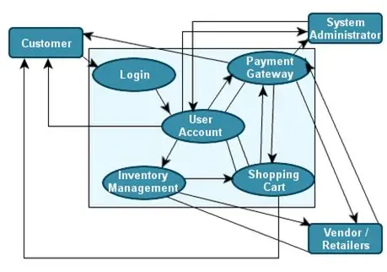

A data flow diagram (DFD) maps out the flow of information for any process or system. It uses defined symbols like rectangles, circles and arrows, plus short text labels, to show data inputs, outputs, storage points and the routes between each destination. Data flowcharts can range from simple, even hand-drawn process overviews, to in-depth, multi-level DFDs that dig progressively deeper into how the data is handled. They can be used to analyze an existing system or model a new one. Like all the best diagrams and charts, a DFD can often visually “say” things that would be hard to explain in words, and they work for both technical and nontechnical audiences, from developer to CEO. That’s why DFDs remain so popular after all these years. While they work well for data flow software and systems, they are less applicable nowadays to visualizing interactive, real-time or database-oriented software or systems.

**Technology stack:**

**A technology stack (or tech stack) is a combination of software products and programming languages used to create a web or mobile application. It includes various components such as:**

* **Frontend Technologies: These are the tools and frameworks used to build the user interface, such as HTML, CSS, and JavaScript frameworks like React or Angular.**
* **Backend Technologies: These include server-side languages and frameworks, such as Node.js, Python, Ruby on Rails, and databases like MySQL or MongoDB.**
* **APIs: Application Programming Interfaces that allow different software components to communicate with each other.**
* **Conclusion:**
* **The Smart Sorting system using transfer learning has shown promising results in identifying rotten fruits and vegetables. By leveraging pre-trained models and fine-tuning them for specific tasks, we can develop accurate and efficient sorting systems. This technology has the potential to reduce food waste, improve food safety, and increase efficiency in the food industry.**
* **Key Takeaways:**
* **1. Transfer learning: Utilizing pre-trained models can improve accuracy and reduce training time.**
* **2. Image classification: Deep learning architectures like CNNs can effectively classify images of fruits and vegetables.**
* **3. Smart sorting: Automated sorting systems can streamline the sorting process, reducing labor costs and increasing efficiency.**
* **Future Directions:**
* **1. Expanding dataset: Collecting and annotating a larger dataset can further improve model accuracy.**
* **2. Exploring other architectures: Investigating other deep learning architectures and techniques can lead to even better performance.**
* **3. Real-world implementation: Implementing the Smart Sorting system in real-world settings can help reduce food waste and improve food safety.**
* Data Collection: Collect or download the dataset that you want to train.
* Data pre-processing
  + Data Augmentation
  + Training and te
* Application Building
  + Create an HTML file
  + Build python code
  + Enter the path to the image: /path/to/image.jpg
  + Output:
  + The image is classified as: Fresh
  + or
  + The image is classified as: Rotten
  + Python Code:
  + import cv2
  + import numpy as np
  + from tensorflow.keras.models import load_model
  + Load the trained model
  + model = load_model('smart_sorting_model.h5')
  + Define a function to classify an image
  + def classify_image(image_path):
  + img = cv2.imread(image_path)
  + img = cv2.resize(img, (224, 224))
  + img = img / 255.0
  + img = np.expand_dims(img, axis=0)
  + prediction = model.predict(img)
  + if prediction[0][0] > prediction[0][1]:
  + return 'Fresh'
  + else:
  + return 'Rotten'
  + Get user input
  + image_path = input("Enter the path to the image: ")
  + Classify the image
  + result = classify_image(image_path)
  + Print the result
  + print(f"The image is classified as: {result}")
  + How it Works:
  + 1. The user inputs the path to an image of a fruit or vegetable.
  + 2. The code loads the pre-trained model and uses it to classify the image as fresh or rotten.
  + 3. The classification result is printed to the console.
  + Assumptions:
  + - The pre-trained model (smart_sorting_model.h5) is already trained and saved.
  + - The image path input by the user is valid and points to a valid image file.
  + Advantages:
  + 1. Improved Accuracy: Transfer learning enables the model to leverage knowledge gained from large datasets, resulting in improved accuracy.
  + 2. Efficient Sorting: Automated sorting systems can quickly identify and separate rotten produce, reducing labor costs and increasing efficiency.
  + 3. Reduced Food Waste: Early detection and removal of rotten produce can help reduce food waste and improve food safety.
  + 4. Increased Efficiency: Smart sorting can streamline the sorting process, reducing labor costs and increasing efficiency.
  + 5. Scalability: The system can be scaled up or down depending on the specific needs of the application.
  + Disadvantages:
  + 1. Data Quality: The quality of the training data can significantly impact the performance of the model.
  + 2. Model Complexity: Deep learning models can be complex and require significant computational resources.
  + 3. Training Time: Training the model can take a significant amount of time, especially for large datasets.
  + 4. Limited Domain Knowledge: The model may not perform well on images that are significantly different from the training data.
  + 5. Maintenance and Updates: The system may require regular maintenance and updates to ensure optimal performance.
  + Mitigating Disadvantages:
  + 1. Data Preprocessing: Implementing data preprocessing techniques can help improve data quality.
  + 2. Model Optimization: Optimizing the model architecture and hyperparameters can improve performance and reduce training time.
  + 3. Regular Updates: Regularly updating the model with new data can help maintain performance and adapt to changing conditions.
  + 4. Domain Adaptation: Implementing domain adaptation techniques can help the model perform well on images from different domains.
  + Conclusion:
  + The Smart Sorting system using transfer learning has shown promising results in identifying rotten fruits and vegetables. By leveraging pre-trained models and fine-tuning them for specific tasks, we can develop accurate and efficient sorting systems. This technology has the potential to reduce food waste, improve food safety, and increase efficiency in the food industry.
  + Key Takeaways:
  + 1. Transfer learning: Utilizing pre-trained models can improve accuracy and reduce training time.
  + 2. Image classification: Deep learning architectures like CNNs can effectively classify images of fruits and vegetables.
  + 3. Smart sorting: Automated sorting systems can streamline the sorting process, reducing labor costs and increasing efficiency.
  + Future Directions:
  + 1. Expanding dataset: Collecting and annotating a larger dataset can further improve model accuracy.
  + 2. Exploring other architectures: Investigating other deep learning architectures and techniques can lead to even better performance.
  + 3. Real-world implementation: Implementing the Smart Sorting system in real-world settings can help reduce food waste and improve food safety.